

**Analysis Report**

## Submission By

Amal Thomas

### INSTRUCTIONS

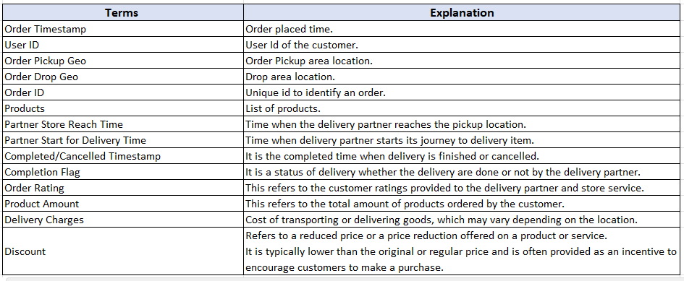

(The data has been given to us from the Fresho Hypermarket)

**The Things to Find**

* **Order level Analysis**
* **Completion Rate Analysis**
* **Customer Level Analysis**
* **Delivery Analysis**

**Order level Analysis**

* **Order distribution at time slot and delivery area level**
* Here we can clearly see the domination of **HSR LAYOUT** for the large number of orders in every time slots and Most of the Orders are at Afternoon, so that might be highly demand for Lunch and more people are working there.
* ITI Layout – This place Is having a greater number of orders after **HSR LAYOUT.** Large number of houses and offices are located in the area, the demand is almost equal for afternoon and morning orders.
* Harlur – This Place is also having a greater number of orders while comparing to other areas and Morning time is having a greater number of orders, so this area is more occurred with houses.
* Bomannahali – MicoLayout- This are can also consider as Office area, because the number of orders is high in the afternoon session.
* **Areas having highest increase in monthly orders (from Jan to Sep)**
* The **SEPTEMBER** month is having a greater number of orders in all delivery areas.
* **HSR LAYOUT** is having clear domination over others areas in monthly orders. In every month this area is having large number of orders and the grand total of orders of this period is **15657.**
* Areas having greater number of orders in every month followed by HSR LAYOUT are
* ITI Layout
* Harlur
* Bomannahali – MicoLayout
* **Delivery charges as a percentage of product amount at slot and month level**
* When comparing to the previous Charts the maximum number of orders have placed in the month of September.
* While considering the delivery charges, it is very high in the months of **January and February.**
* We can easily establish that number of orders are high then the rate of delivery charges is very less, the most important thing is September month is having lowest rate of delivery.
* The **Late-Night** Orders are having the large amount of delivery charges while comparing with other time slots.
* **Discount as a percentage of product amount at slot and month level**
* When considering all the time slot **August** Month is having greater amount of discount given to every customer.
* **September** is the second highest month while September is having the greatest number of orders.
* Here we can understand that the customers are very interested to purchase items at the mid of the year. We can also mention Due to high discount the number of orders is high in these 2 months.
* **Discount as a percentage of product amount at drop area and slot level**
* **Bilekahali** - This place is having Highest percentage of discount rate at all the time slots.
* When comparing the number of orders of this place to others, the number of orders are very less.
* So, this might be to attract more customers from lower level of order areas. Other areas are having a decent level of order in every month but in Bilekahali the number of orders and revenue are very less.
* This may be because of the poor status of customers (eg: middle class family) who are unwilling to order to order form hypermarket rather than purchasing from local shops.

**Completion Rate Analysis**

* **Completion rate at slot vs day of the week (Sunday to Saturday) level**
* The completion rate is **Total number of product successful delivered/Number of orders placed**.
* Here we can see the completion rate is very much similar in all time slots and every week.
* The completion rate is top high at **Evening and Morning** Time slots also the least completion rate is at late night orders.
* This might be because of **not attending the calls from delivery executive**.
* Technical issues from the company side to smoothly run the application.
* In the weekend days, the number of orders is high and in other days the rate is almost similar.
* **Completion rate at drop area level**
* The order completion rate is almost similar in every area
* But in some areas the order completion rate is less. This might be because of **travel issues** and **network issues**.
* In the case of number of orders placed in the area Bommanahalli, the completion rate is Low. This is might be due of traffic issues, network issues.
* **Completion rate at number of products ordered level**
* When we observe the completion rate is very near to **100%**
* When the number of products orders are high then it showing better completion rate
* The data saying that large number of orders are placed well without any failure
* When we have small number of orders, the completion rate is low, so it’s important to keep completion rate 100% in all the kind of orders.
* **Give you analysis on the any pattern you observe in the completion rate**
* When we observe the completion rate is very near to 100%.
* When the number of product order are high then it showing better completion rate.
* When we have **small number of orders, the completion rate is low**.
* Completion rate is very high in the cities which have **good transportation facilities and networks.**
* Network and traffic have affected the delivery of the products completely.
* **Lack of communication** may be also an issues with this completion rate.
* Most of the completion rate are **100% or 0.9%.**

**Customer Level Analysis**

* **Completion rate at source level**
* It is clearly visible that the users of **Instagram** are well dominating the data.
* This is clearly saying that **youngsters** are the majority of the customers who's order online.
* Here the interesting part is **Organic source** are leading with the greatest number of orders but Instagram leading with most completion rate.
* Here we can understand that the use of online source has significantly attracted youth and **proper communication** has taken place to finish the orders at stipulated time.
* **LTV for every customer**
* The highest revenue from customer **ZQB198457 is 54804**
* Most of the customers LTV falls between **1000- 10000**
* **Aggregated LTV at customer acquisition source level**

|  |  |  |
| --- | --- | --- |
| **User ID** | **Sum of Product Amount** | **Aggregated LTV** |
| Facebook | 921851 | 1296.555556 |
| Google | 1939010 | 2153.857477 |
| Instagram | 192096 | 1292.918654 |
| Offline Campaign | 1008411 | 1249.120596 |
| Organic | 2287431 | 1973.985011 |
| Snapchat | 936767 | 1330.232323 |
| **Grand Total** | **7285566** | 9296.669616 |

* The revenue generated from **Google source** is far high while comparing to other sources
* The most customers who search on google to find their required product and went to Fresho Hypermarket website and found the products.
* So here **Search engine optimization** is playing relevant role to attract the customer to the company.
* Aggravated LTV on Google base is **2153.85**
* Other sources are playing role as usual.
* **Aggregated LTV at acquisition month level**

|  |  |  |
| --- | --- | --- |
| **User ID** | **Sum of Product Amount** | **Aggregated LTV** |
| Jan | 492042 | 803.9901961 |
| Feb | 515308 | 1509.331288 |
| Mar | 658055 | 1473.179641 |
| Apr | 801288 | 1038.063291 |
| May | 884944 | 838.2316865 |
| Jun | 835248 | 1308.62234 |
| Jul | 872274 | 1944.83004 |
| Aug | 1034771 | 1362.99723 |
| Sep | 1191636 | 1152.323185 |
| **Grand Total** | **7285566** |  |

* **September and August** months are more Revenue generated months.
* As we already seen September and August are dealing with the greatest number of orders and the increase of order rate is at the mid of a year.
* In the case of Aggregated LTV from months it is different, the aggregated LTV months are **July and February**.
* Here the finding is the number of orders is less in these both months but the purchase amount of all customers are high while comparing with other months.
* **Average Revenue (Product amount after discount) per order at different customer acquisition source level**
* **Facebook** is the highest revenue generated source with **32%**.
* **Google is in second position with 27%.**
* In the case of **Aggregated LTV Google was the leading one** but considering the overall revenue generated **Facebook** is on the top.
* Here the fact is the product amount has calculated after deduction of discount, then we can assure that the rate of discount for **Facebook customers are very high.**
* So, there might be an advertisement has done in Facebook with some offers so that’s attracted majority of customers to purchase the products.
* The revenue from **Facebook is 2161368**.
* **Average Revenue per order at acquisition month level**
* The average Revenue on the base customer acquisition month level which provides clear statement that the month **January** is generated Most revenue with **42%**.
* **February** is in the second position with **12%**.
* So, in the start of year the company must be **dealt with several advertisements and offers** to attract more customers in the start of year.
* Some **New year offers and, discounts** made more customers attracts to the Hypermarket and generate more revenue.
* Here also the product amount calculated after deduction of discount, so we can confirm there were high level of advertisement and discounts are given in January and February.
* **Is there any pattern in order rating across slots, number of items placed, delivery charges, discount.**
* Here the thing is when the number of orders goes more than **5000 then average delivery charges is low, if the number of orders are less than 1000 then the average delivery charges are little high comparing to others**.
* The same scenario is for the average discount.
* So, the increase in orders can decrease the delivery charges and increase the discount rates.
* **Number of orders less than 100** in all the time slots except late-night are marked under **1 ,2 and 3 ratings**.
* **Order between 100 and 1000** are rated as **4** in all the timeslots except late-night.
* **Above 1000 orders are rated 5** except late-night.
* So, the late-night orders are considering that important and not providing better rate of discounts while comparing to other time slots.

**Delivery Analysis**

* **Average Overall Delivery Time at Month and Delivery area level**
* The Delivery Charges are almost similar in all the month and increasing the delivery time when the month going.
* The Average Delivery time in all the month is **30mints to 1 Hour.**
* This states that all the areas are very **traffic congested routes** and routes and Little difficult to reach.
* The area **Mahadevapura** is consuming around **2.5 hours** to reach the delivery address that might be because of the technical and any other issues from the hypermarket side.
* For the Better delivery time they should fix a **delivery circle and limit the delivery kilometer** so they can easily treat the customers and deliver it on time.
* **Long delivery will affect the time of delivery of products in the nearest and daily routes**.
* **Average overall Delivery time at month and Weekend/Weekday level.**
* The delivery time in the month of **April and May** are high while others are little less in both weekdays and Weekends.
* This is because in India the school and collages are having **vacation** in the month of April and May. So, the **traffic will get increase by most of the people use cars instead of bikes**.
* Number of orders should be low in this month but due to **staff shortage and Traffic issues** should be the major reason for this scenario.
* **Average Overall Delivery Time at Slot Level**.
* The average Overall Delivery Time is equal in day time like in **3 time slots with 22%**
* But when coming to **night and Late-night** the **Average overall Delivery Time is 19% and 15% respectively**.
* The traffic and availability or part-time staffs are the major reason behind the condition. In the day time most of people go for works and other purpose that can make more congestion and in the night and Late-night should be tariff less and more availability of delivery staffs makes little time to deliver goods.
* **Pattern in delivery charges in slot level**
* The delivery charges are very well grouped with **demand slots**.
* In the **afternoon** most of the people will be at work and most of house wives will purchase something to make it in the evening.
* The **morning and night** timeslots are also crucial demanding section, families are preferring to purchase the items required in the morning or night.
* The **late-night orders** are very less so the charges also very less, less amount of delivery charges will increase the number of deliveries, this is also considered as a marketing strategy.
* **Pattern in Delivery Time and Delivery Area.**
* The **delivery time** is very well **limited within 1 hours.**
* Except 4 areas, **Brookfield, Pattandur, Richmond Twon, Viamanapura** these areas are taking minimum 1 hour to reach the products.
* The **traffic, technical issues from customer, long routes, Poor condition of roads and failure of proper answers by customers to provide the exact information about delivery areas** can consider as a reason for the time delay.